1.15 Basic UI and Data Management

Basic Framework:
Today I officially began creating the MVP product. I broke down the overall MVP product into three parts: a points management system, a resource management system, and the linkage between the two systems. I'll start with the points management system. For this system, the MVP standard is:
- Have a data structure to store student’s data.
- Have the form for updating the points of students(add/minus).
- Have transaction record for every points modification(include time, student, delta, reason, description, operator and update the record). The event log is append-only, ensuring auditability.
- Have the ability to calculate the points of every student automatically and create a rank for teacher to reference.
I used the ChatGPT tool to write the HTML code according to my ideas and structure, and I will explain the framework and implementation of this system in the following sections.
Basic idea of the system:
This web app can be understood as a three-layer system (From the backside to frontside):
- Data layer.
This is the most essential part of the entire system and what users truly need to manage. It stores:
- A student dataset (e.g., name, ID, grade, points etc.)
- A points event log (transaction record) where each entry represents a single points change with metadata (ID, date, delta, description, operator).
The system does not treat the displayed points as the sole data source, but instead recalculates the points based on the event logs when needed (e.g., after a correction), thereby improving consistency and auditability.
- Structure layer.
The structure layer is the fixed UI skeleton built by HTML and CSS:
- Left panel: grade tabs + student search + student list.
- Right panel: selected student card + points modification form + ranking + event table
This layer defines where information appears and how the interface is organized, but it does not contain the actual dynamic data.

- Rendering layer:
The rendering layer connects the data to the UI. JavaScript:
- Filters students/events by the current grade and search keywords.
- Injects the processed result into static HTML layout.
- Keeps the UI consistent by re-rendering after every user action (e.g., submit event, correction, choose a student from the list).
Data layer:
This layer defines the system state and the audit trail. It contains two data structures:
- Student dataset (students)
Stores the current snapshot of each student:

Field | Type | Example | Meaning
id | string | “1001” | Unique student identifier
grade | string | “G1” | Grade of this student
class | string | “G1-1” | Class of this student
name | string | “Alex Wang” | Name of this student
points | int | 7 | Points of this student

Purpose: provides fast access for listing students and displaying the current score.
- Points event log (events)
Records every points change as an immutable transaction:

Field | Type | Example | Meaning
event_id | string | “f47ac10b-58cc-4372-a567-0e02b2c3d479” | Unique event identifier
time | string | “2026-01-19…” | Time stamp
student_id | string | “2002” | Modified student ID
delta | int | +3 | Delta points of this event
type | string | “课堂表现” | Reason for this event
description | string | “Answer question actively” | Additional information for this event
operator | string | “TeacherA” | The operator of this event

Purpose: preserves a complete history for transparency and accountability.
To avoid drift or corruption, the system can rebuild all students’ points from the event log by summing delta per student_id. (implemented in rebuildPointsFromEvents), ensuring the displayed scores always match the recorded history. In this MVP, both datasets are stored as JavaScript arrays. In later updates, these arrays can be replaced by a spreadsheet/database interface while keeping the same data model.

Structure Layer:
This layer provides the static UI skeleton of the web app. It defines where information appears, while rendering layer decides what content is displayed. The skeleton has left and right panel (As shown in Fig. R1).

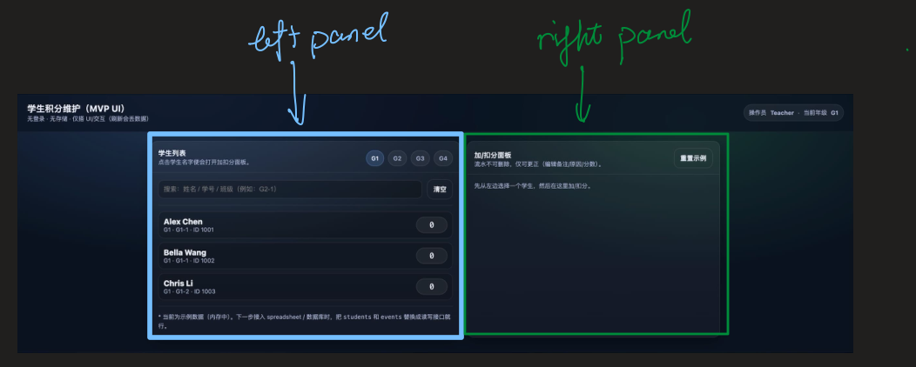
Figure R1. Overall UI Layout (left panel: navigation; right panel: operations)

Left panel | Right panel
Static components:  - Search box (filter student by keyword)  - Switch grade button (filter student by grade)  - Student list container (list of student after filtering) | Static components:  - Selected student card (name/class/id/points…)  - Points modification form (delta, reason…)  - Points ranking container  - Points event history table

Specific entries and information in the container belong to the rendering layer while the structure and template belong to structure layer (As shown in Fig. R2).
Linkage: Clicking on a specific student entry on the left panel will re-render the content of the panel on the right.

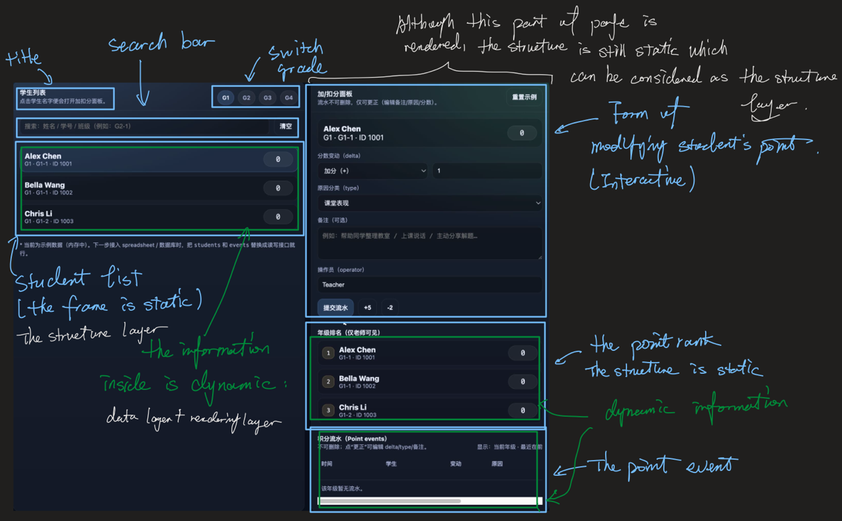
Figure R2. The Structure of UI Skeleton (blue: structure layer; green: rendering layer)

Rendering layer:
The rendering layer acts like the bridge for the data layer and the UI skeleton. The rendering layer is responsible for displaying specific information on the webpage. It embeds this information from data layer into static framework provided by the structure layer.
Whenever the user performs an action, the system updates state/data first, then triggers a re-render:
User action $→$ state/data update $→$ renderAll() $→$ UI refresh
There are three major functions: renderTabs(), renderStudentList(), renderSelectedPanel(), and they are all controlled by a central control function renderAll().
Function | Meaning
renderAll() | Executes renderTabs(), renderStudentList(), renderSelectedPanel(). Keep the UI consistent after any state change
renderTabs() | Renders grade-selection buttons and highlights the active grade (activeGrade)
renderStudentList() | Filters the students dataset by grade and search query, then renders matching student entries.
renderSelectedPanel() | Renders the right panel, including the selected student card, point modification form, grade ranking, and filtered event history table (from students and events)

Example: submitting a point change:
- User submits the form $→$submitEvent() is triggered.
- A new event record is constructed and appended to events
- Points are updated (directly or by recomputing from the event log)
- renderAll() refreshes the student list, ranking, and event table.
“Re-render after every action” approach is simple and reliable for small-scale MVPs.
For future scaling, rendering could be optimized so only affected UI modules update instead of re-rendering everything.

